PROJECT REPORT

VISUALIZATION TOOL FOR ELECTRIC VEHICLE CHARGE AND RANGE ANALYSIS

1.Introduction

1.1 Overview

For many electric car drivers, this is a reality. Battery-electric cars never need gas, and for short trips, plug-in hybrids might use no gas. Electric car charging is simple, cost-effective and convenient, particularly when you are plugged in at home—filling up your car even while you’re asleep. How long it takes to charge depends on the charging equipment and the size of the car’s battery and its available charging capacity. Although electric car drivers primarily charge at home, workplace and public chargers are increasingly available in communities nationwide.

1.2 Purpose

Vehicle power electronics primarily process and control the flow of electrical energy in hybrid and plug-in electric vehicles, including plug-in electric vehicles. They also control the speed of the motor, and the torque it produces.

Electricity is an essential part of modern life and important to the U.S. economy. People use electricity for lighting, heating, cooling, and refrigeration and for operating appliances, computers, electronics, machinery, and public transportation systems.

Electrical design is important because it ensures that the electrical system is safe, efficient, and meets all applicable codes and regulations. It is also responsible for ensuring that the system is durable and will stand up to the wear and tear of daily use.

A ***Battery Electric vehicle*** has fewer moving parts than a conventional petrol/diesel car. Servicing is relatively easy, less frequent and overall cheaper than a petrol/diesel vehicle. All EV batteries degrade (become less efficient). Most car manufacturers warrant EV batteries to not degrade below a certain level for around eight years.

2.Problem definition and design thinking

2.1 Empathy map

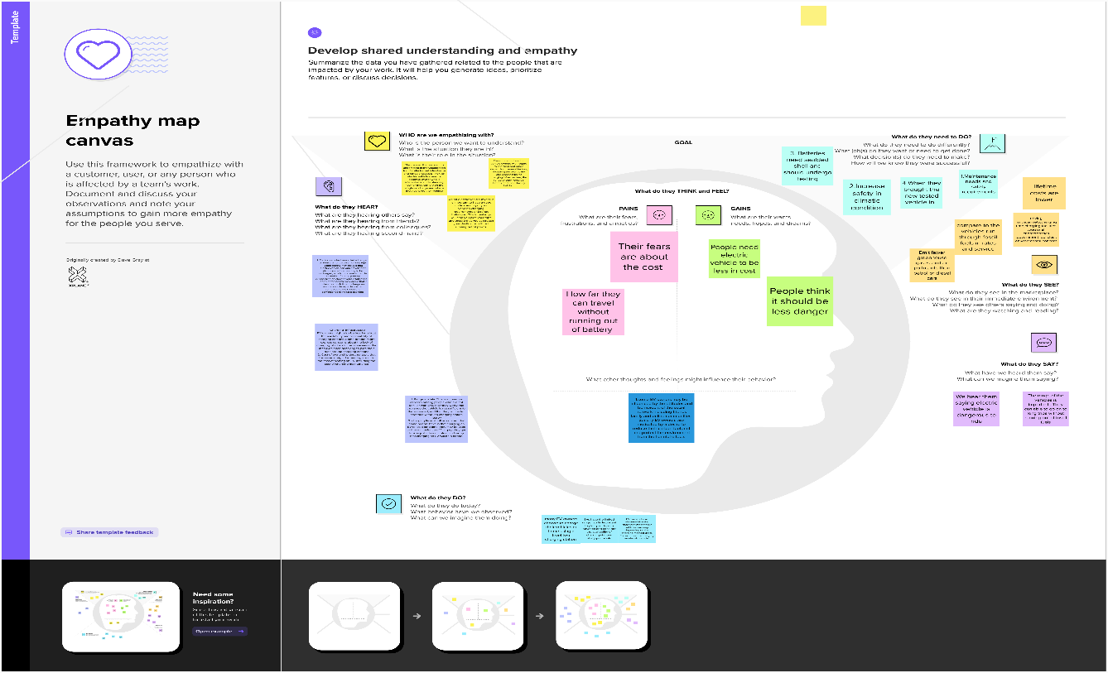

2.2 Ideation and Brainstorming Map

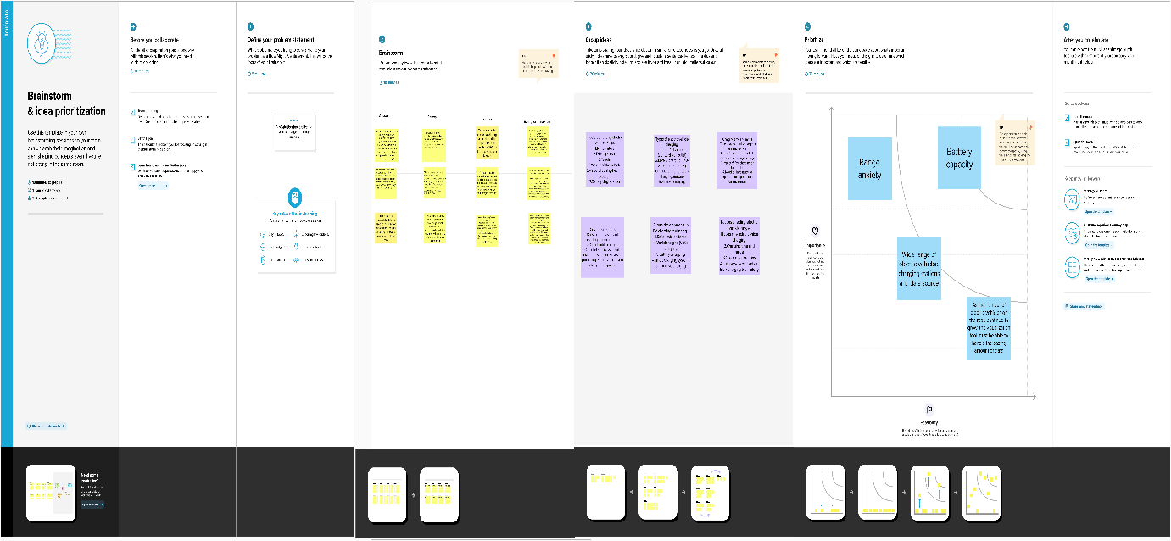

3.Result

Activity and screenshots

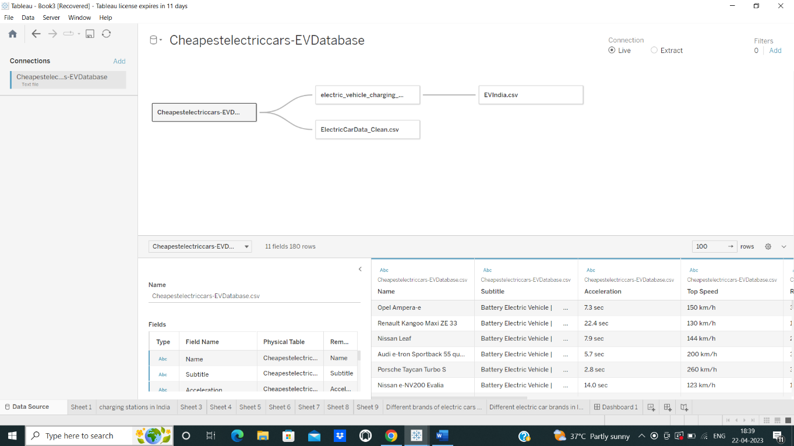

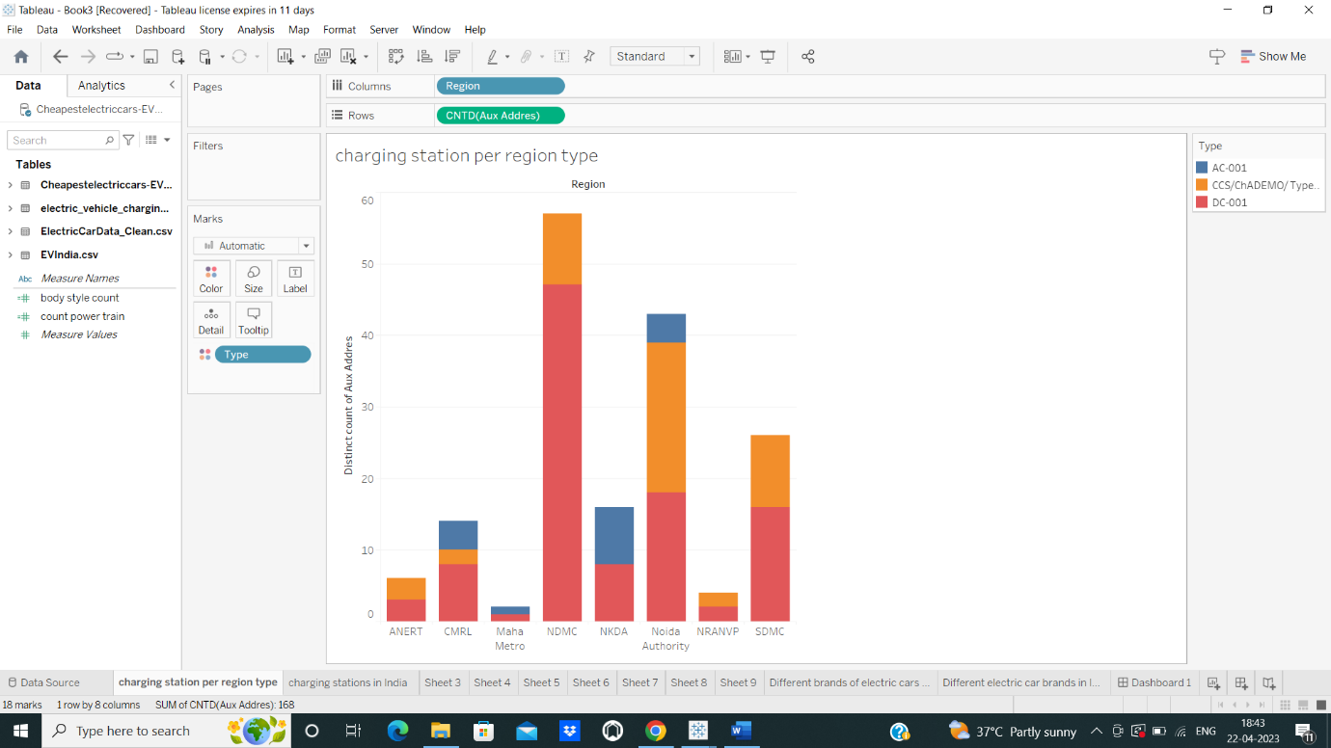

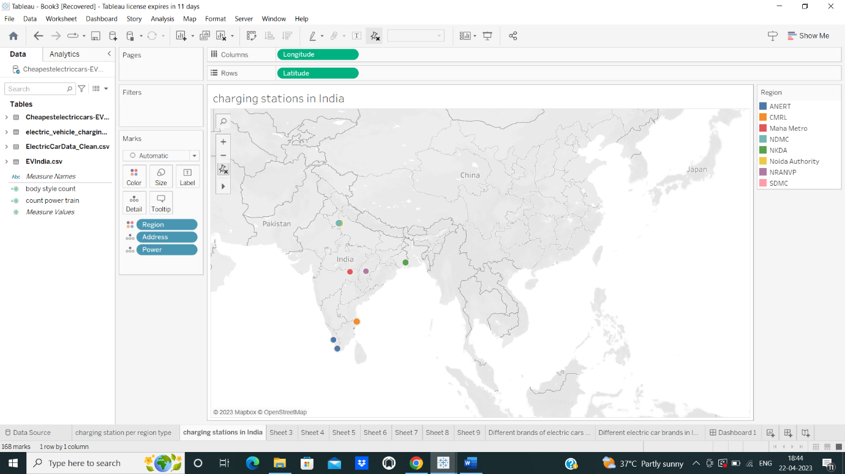

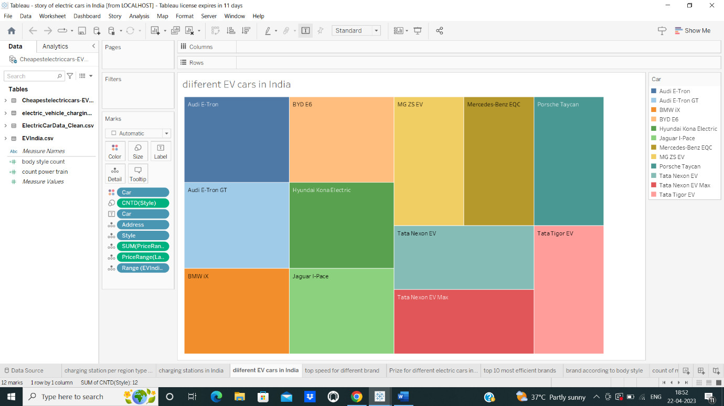

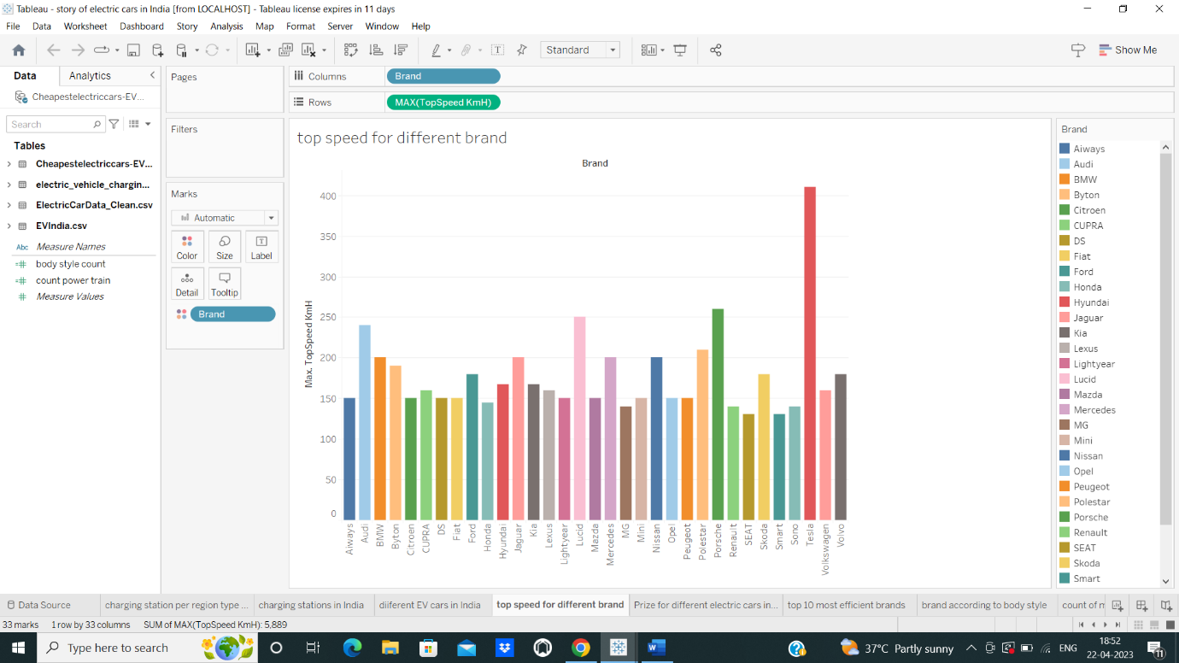

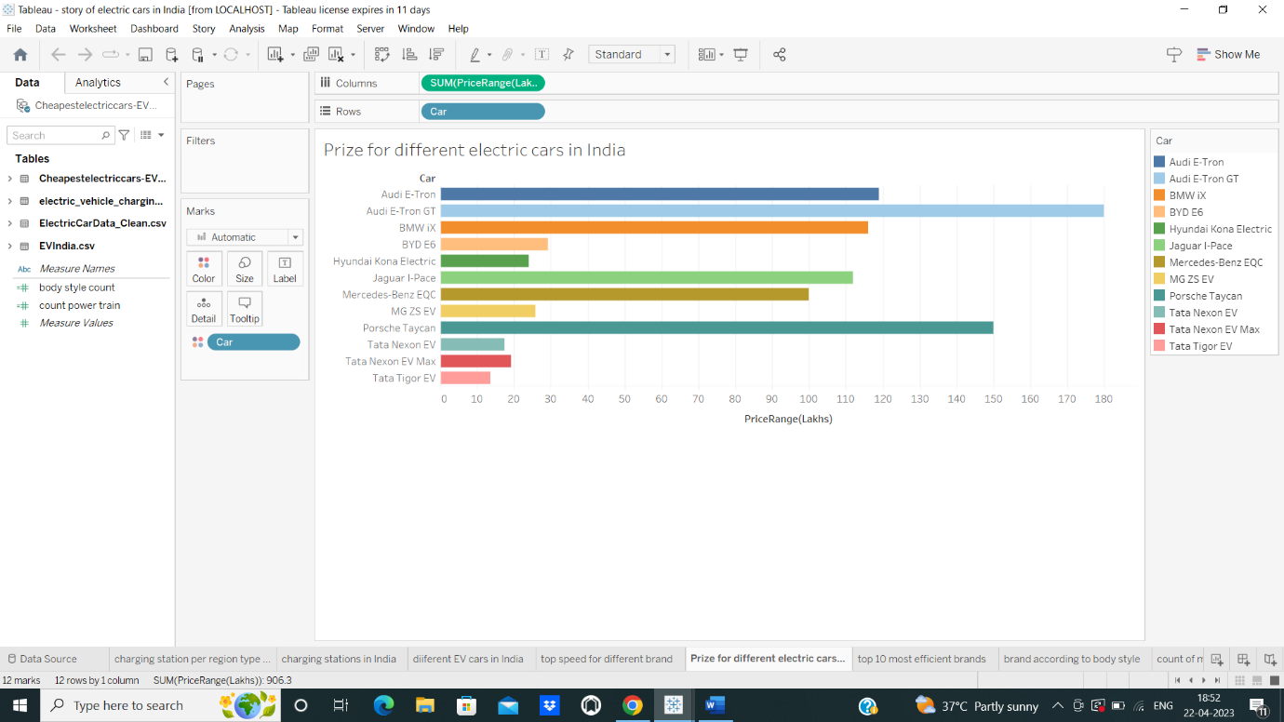

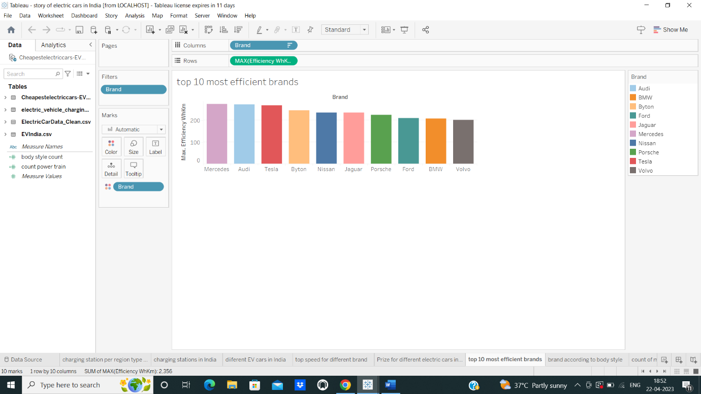

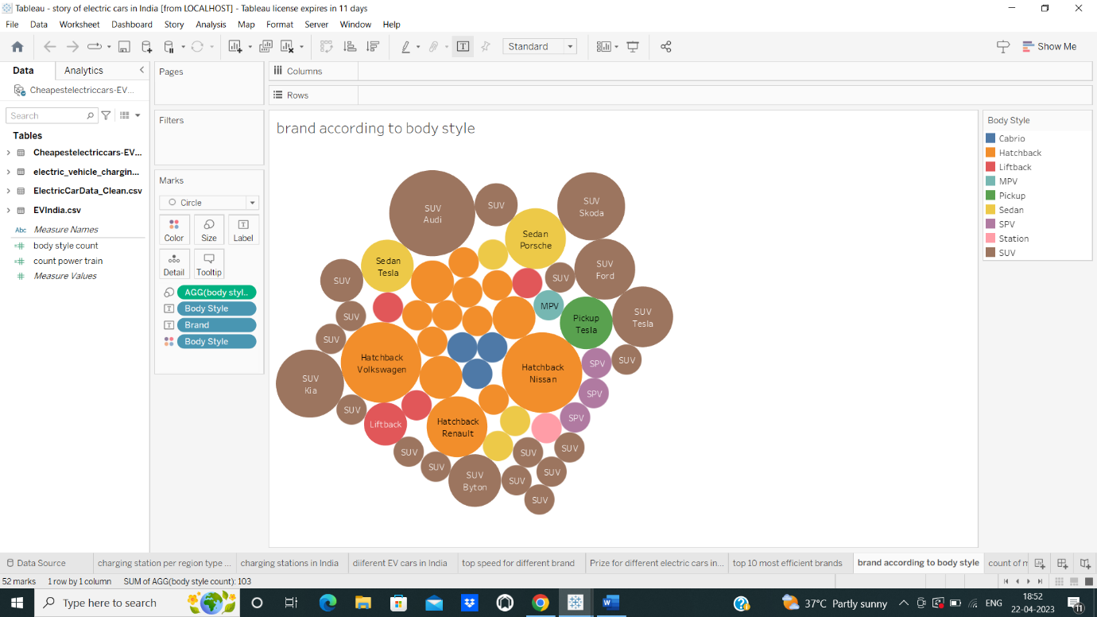

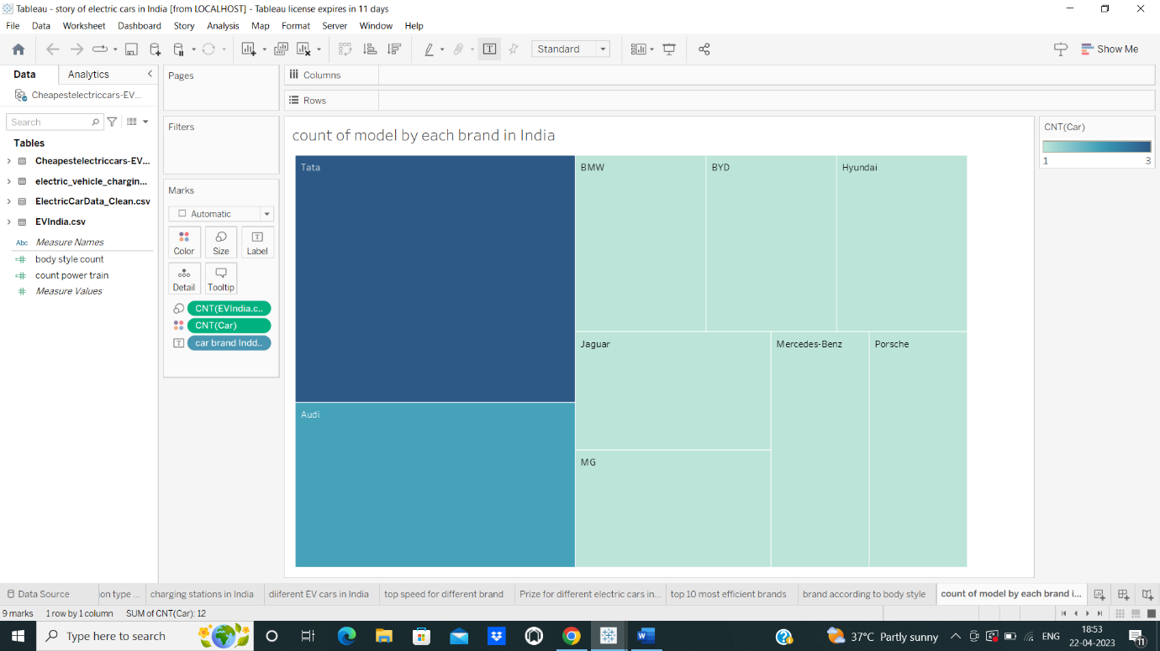

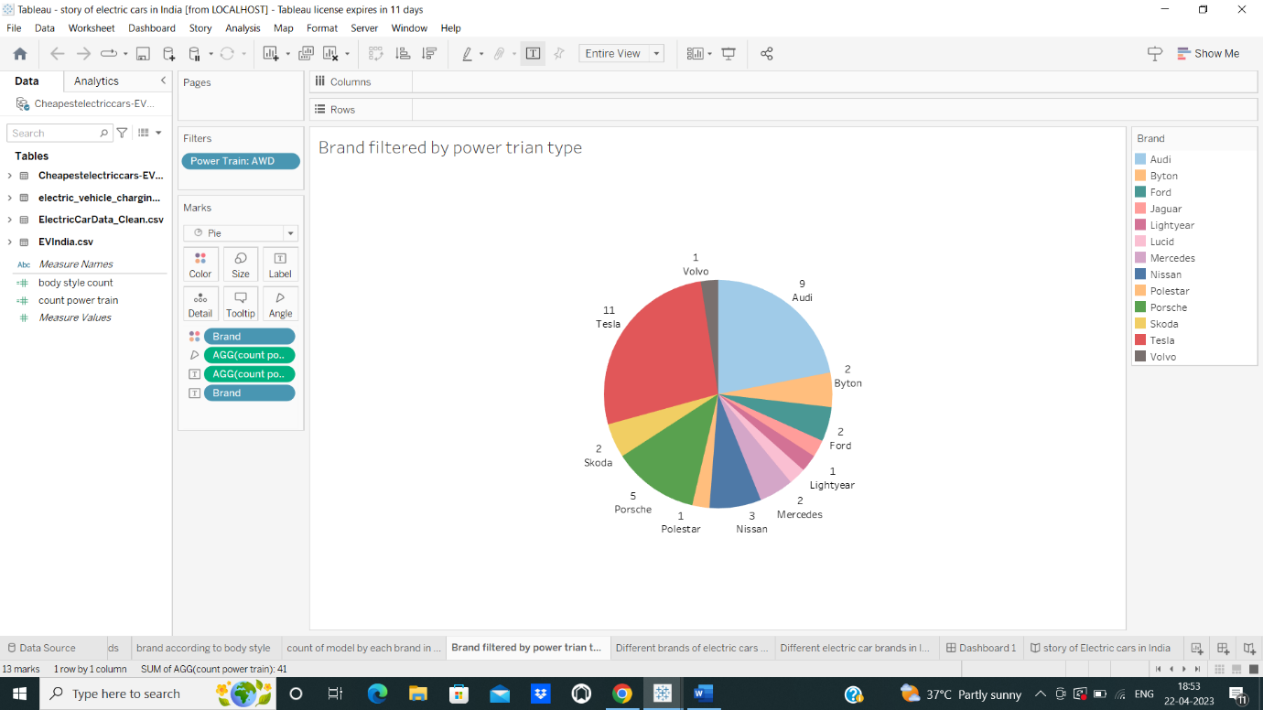

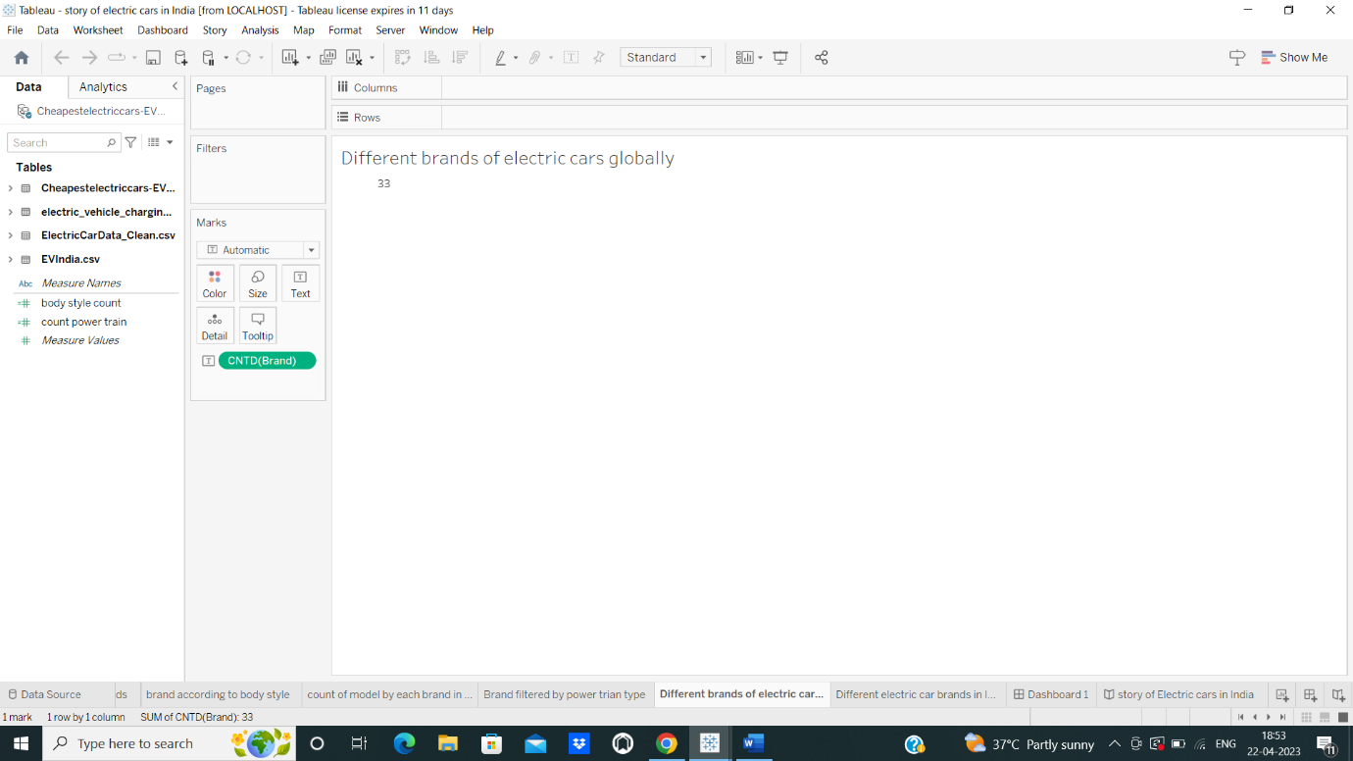

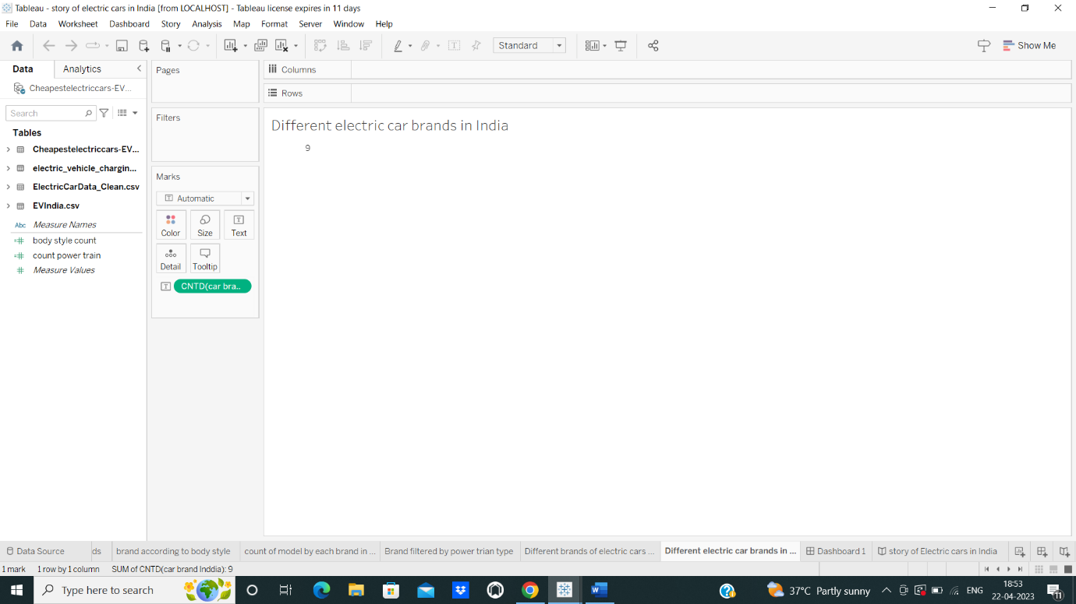

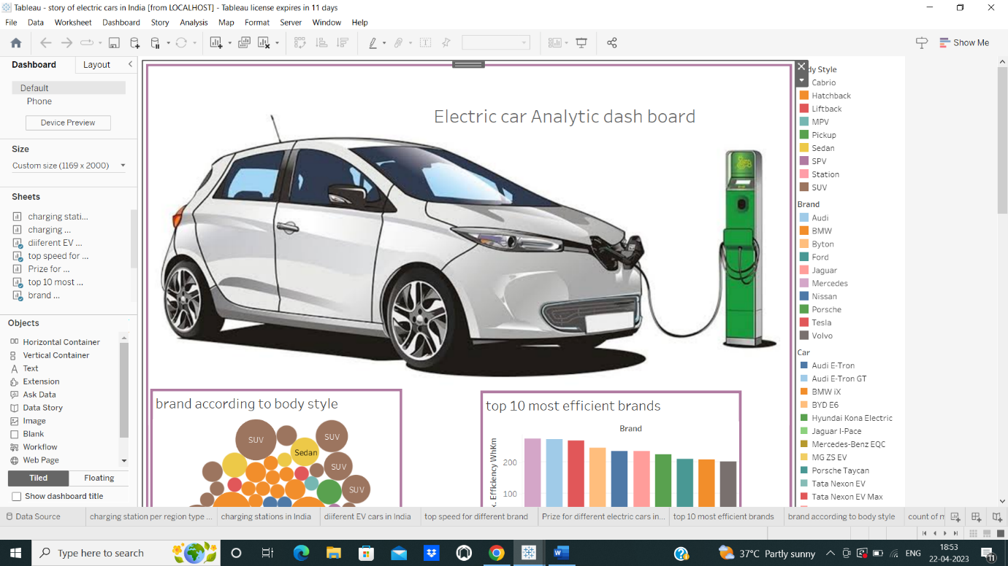

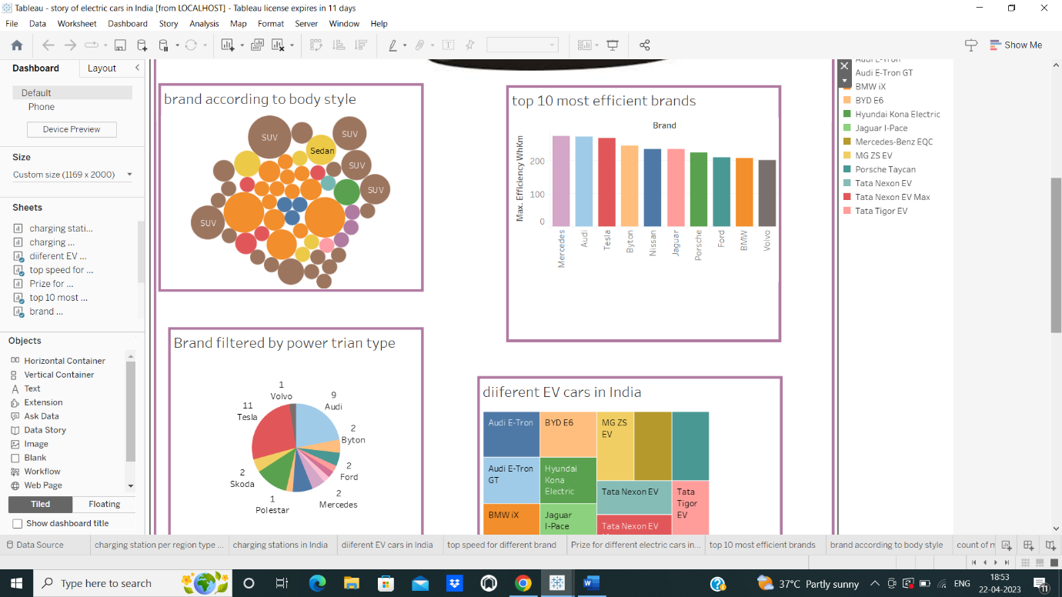

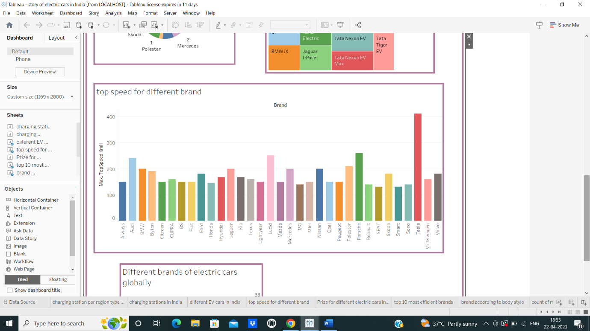

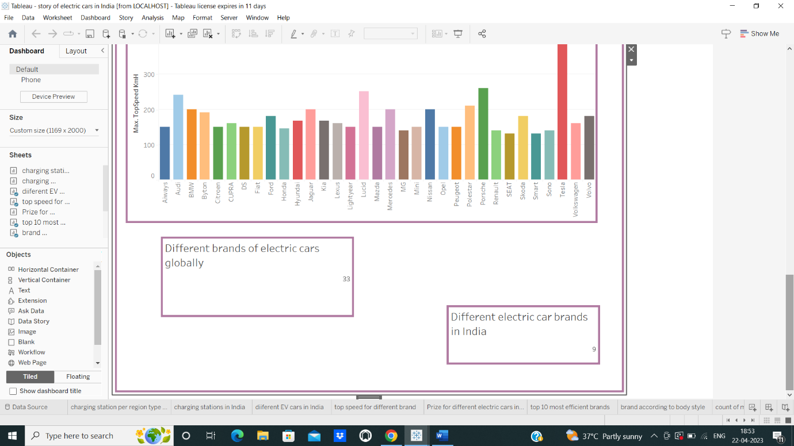

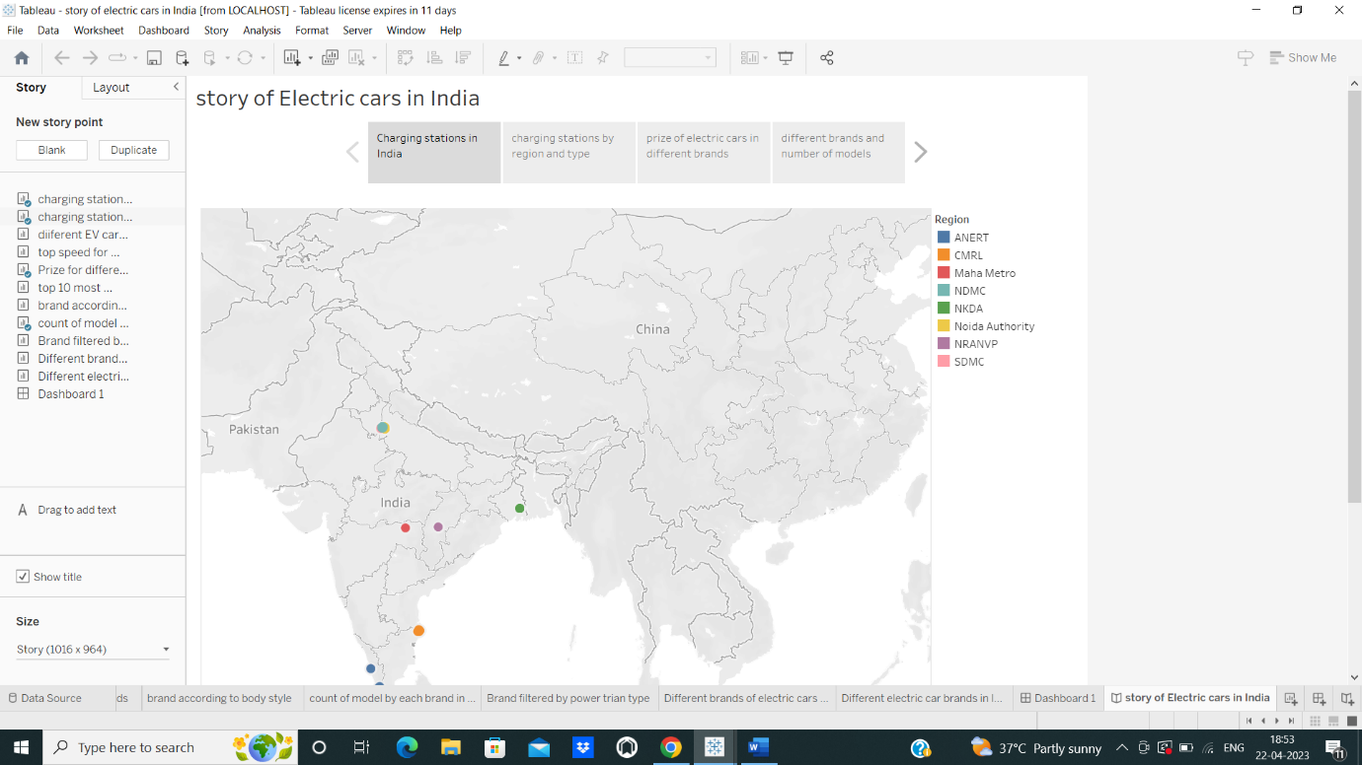

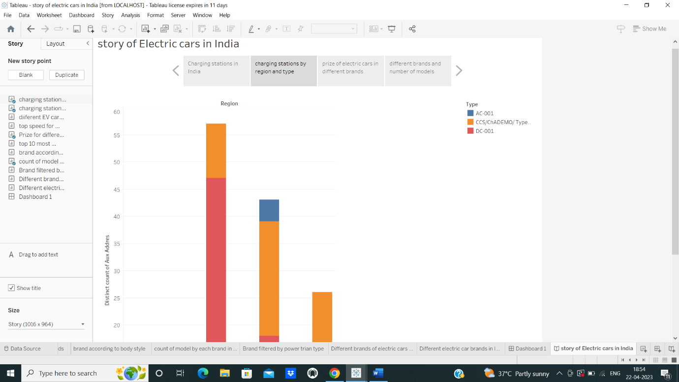

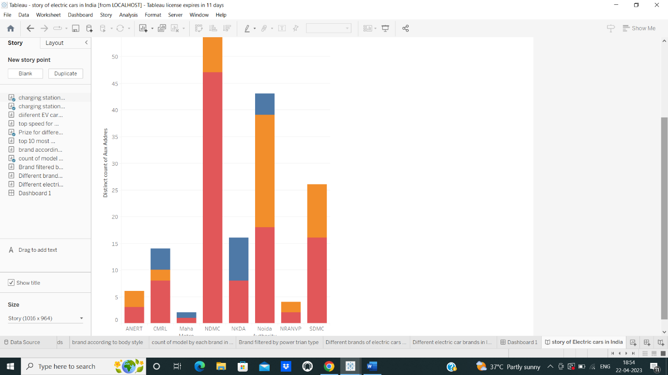

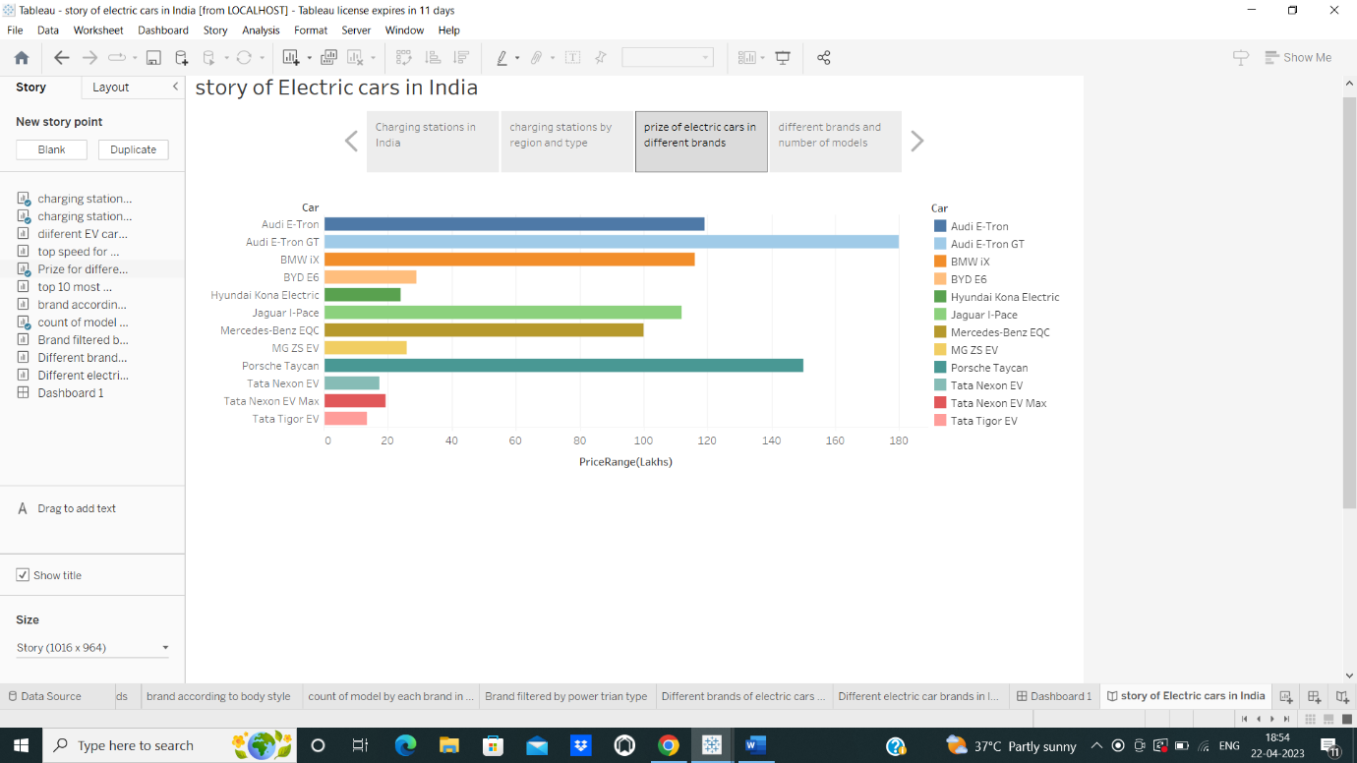

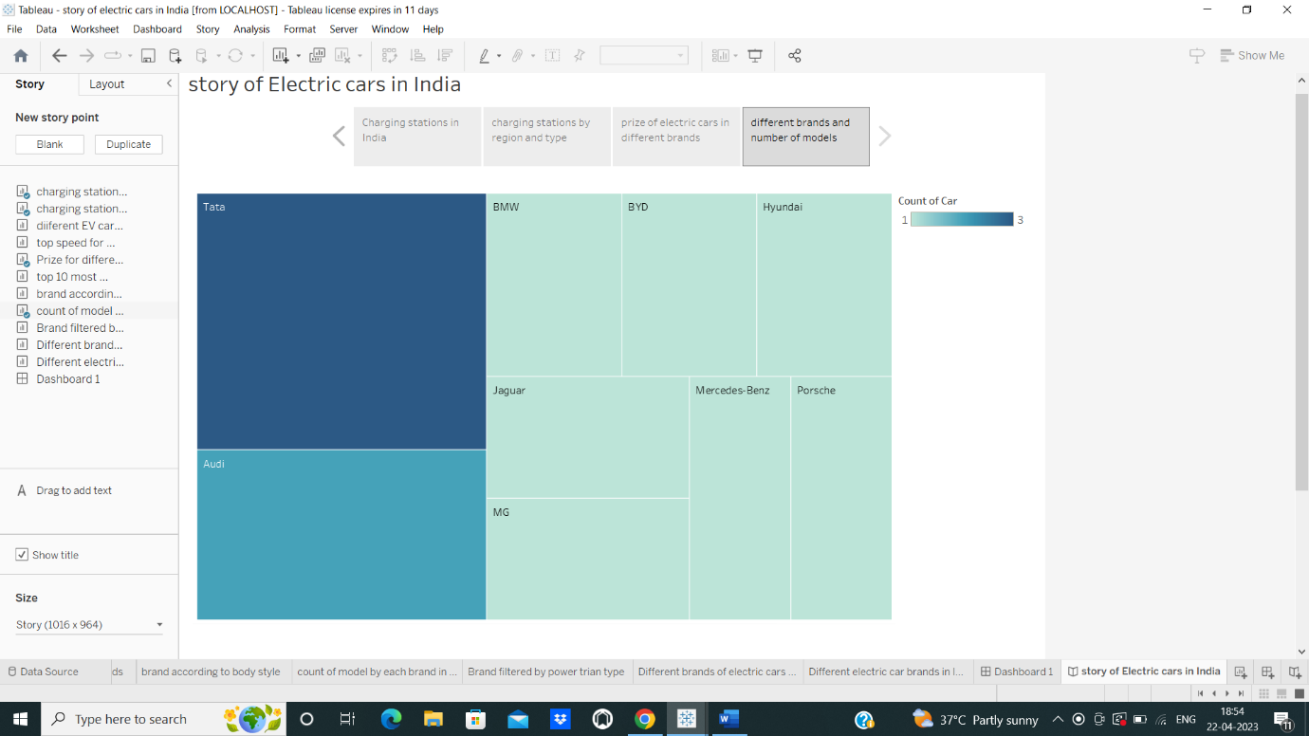

4. Trailhead profile Public URL

Team lead - <https://trailblazer.me/id/anusuya0712>

Team member 1 - <https://trailblazer.me/id/ramya0112>

Team member 2 - <https://trailblazer.me/id/azhagiyamanavalan2309>

Team member 3 - <https://trailblazer.me/id/sathyag04>

5. Advantage and Disadvantage

Advantages of Electric vehicle

1. Lower running costs
2. Low maintenance card
3. Tax and financial benefits
4. Better performance

Disadvantage of Electric vehicle

1. Battery Lifespan Concerns

2. Charging Infrastructure Worries

3.Long Charging Times.

4.Low Top Speeds.

6.Applications

**Reduced population** transportation sector is now the largest source of carbon dioxide emission in U.S. The continue integration EVs with help reduce this impact because they produce 54% less carbon dioxide emission per mile than a convention vehicles

**Economic growth** According to the U.S. department of energy in 2017 the U.S imported 19% of petroleum it used. Using Electric vehicles can reduce our energy dependency abroad and support the U.S economy through the generation of new jobs, particularly in skilled electrical trades

**Increased Sales** Consumers are demonstrating strong interest in EVs and increasing demand. EVs accounted for only 1.3 percent of total vehicles sold in the U.S. in 2017 .By third quarter 2018,that had nearly doubled to 2.5 percent; hitting 3 percent by the fourth quarter

**Cost savings** EV batteries convert 59 to 62 percent of energy into vehicle movement while gas powered vehicles use 17 and 21 percent EV drives spend about $1.2 per gallon to charge less than half the price of gasoline. The average operating cost of an EV is $485 annually compared to $1.117 for a conventional vehicle.

7.Conclusion

The progress that the electric vehicle industry has seen in recent years is not only extremely welcomed, but highly necessary in light of the increasing global greenhouse gas levels. As demonstrated within the economic, social, and environmental analysis sections of this webpage, the benefits of electric vehicles far surpass the costs. The biggest obstacle to the widespread adoption of electric-powered transportation is cost related, as gasoline and the vehicles that run on it are readily available, convenient, and less costly. As is demonstrated in our timeline, we hope that over the course of the next decade technological advancements and policy changes will help ease the transition from traditional fuel-powered vehicles. Additionally, the realization and success of this industry relies heavily on the global population, and it is our hope that through mass marketing and environmental education programs people will feel incentivized and empowered to drive an electric-powered vehicle. Each person can make a difference, so go electric and help make a difference

8.Future scope

Electric vehicles (EV) is the future not only of transport but of our planet. Can electric vehicles ever face a more serious form of gridlock however? These vehicles are plugged into a charging station at a low voltage. There are no emissions released from these vehicle

The future potential of electric vehicles is enormous. The obvious starting point for these vehicles is the charging station. This is however only the first step in a potential journey which will see charge Banks and other industrial areas as well as homes and cities. The future scope of electric vehicles is therefore massive.

The future scope of electric vehicles is therefore enormous. We have already seen that technology for these vehicles is here and becoming far more advanced. We now know that such vehicles can provide us with great flexibility and we will soon see that potential.

9.Appendix

<!DOCTYPE html>

<html lang="en">

<head>

  <meta charset="utf-8">

  <meta content="width=device-width, initial-scale=1.0" name="viewport">

  <title>Electric Cars Analytics</title>

  <meta content="" name="description">

  <meta content="" name="keywords">

  <!-- Favicons -->

  <link href="assets/img/favicon.png" rel="icon">

  <link href="assets/img/apple-touch-icon.png" rel="apple-touch-icon">

  <!-- Google Fonts -->

  <link href="https://fonts.googleapis.com/css?family=Open+Sans:300,300i,400,400i,600,600i,700,700i|Nunito:300,300i,400,400i,600,600i,700,700i|Poppins:300,300i,400,400i,500,500i,600,600i,700,700i" rel="stylesheet">

  <!-- Vendor CSS Files -->

  <link href="assets/vendor/aos/aos.css" rel="stylesheet">

  <link href="assets/vendor/bootstrap/css/bootstrap.min.css" rel="stylesheet">

  <link href="assets/vendor/bootstrap-icons/bootstrap-icons.css" rel="stylesheet">

  <link href="assets/vendor/glightbox/css/glightbox.min.css" rel="stylesheet">

  <link href="assets/vendor/remixicon/remixicon.css" rel="stylesheet">

  <link href="assets/vendor/swiper/swiper-bundle.min.css" rel="stylesheet">

  <!-- Template Main CSS File -->

  <link href="assets/css/style.css" rel="stylesheet">

  <!-- =======================================================

  * Template Name: FlexStart - v1.12.0

  * Template URL: https://bootstrapmade.com/flexstart-bootstrap-startup-template/

  * Author: BootstrapMade.com

  * License: https://bootstrapmade.com/license/

  ======================================================== -->

</head>

<body>

  <!-- ======= Header ======= -->

  <header id="header" class="header fixed-top">

    <div class="container-fluid container-xl d-flex align-items-center justify-content-between">

      <a href="index.html" class="logo d-flex align-items-center">

        <img src="assets/img/logo.png" alt="">

        <span>E-CarStart</span>

      </a>

      <nav id="navbar" class="navbar">

        <ul>

          <li><a class="nav-link scrollto active" href="#hero">Home</a></li>

          <li><a class="nav-link scrollto" href="#about">About</a></li>

          <li><a class="nav-link scrollto" href="#values">Dashboard</a></li>

          <li><a class="nav-link scrollto" href="#services">Story</a></li>

          <li><a class="nav-link scrollto" href="#team">Team</a></li>

          <li><a class="nav-link scrollto" href="#contact">Contact</a></li>

          <li><a class="getstarted scrollto" href="#about">Get Started</a></li>

        </ul>

        <i class="bi bi-list mobile-nav-toggle"></i>

      </nav><!-- .navbar -->

    </div>

  </header><!-- End Header -->

  <!-- ======= Hero Section ======= -->

  <section id="hero" class="hero d-flex align-items-center">

    <div class="container">

      <div class="row">

        <div class="col-lg-6 d-flex flex-column justify-content-center">

          <h1 data-aos="fade-up">We offer modern Analytics solutions for Electric Vehicles</h1>

          <div data-aos="fade-up" data-aos-delay="600">

            <div class="text-center text-lg-start">

              <a href="#about" class="btn-get-started scrollto d-inline-flex align-items-center justify-content-center align-self-center">

                <span>Get Started</span>

                <i class="bi bi-arrow-right"></i>

              </a>

            </div>

          </div>

        </div>

        <div class="col-lg-6 hero-img" data-aos="zoom-out" data-aos-delay="200">

          <img src="assets\img\12085817_20944306.jpg" class="img-fluid" alt="">

        </div>

      </div>

    </div>

  </section><!-- End Hero -->

  <main id="main">

    <!-- ======= About Section ======= -->

    <section id="about" class="about">

      <div class="container" data-aos="fade-up">

        <div class="row gx-0">

          <div class="col-lg-6 d-flex flex-column justify-content-center" data-aos="fade-up" data-aos-delay="200">

            <div class="content">

              <h3>E-Car Start</h3>

              <h2>E-Cart Start is a complete analytics tool for electric vehiles all over the world.</h2>

              <p>

                The Electric Vehicle (EV) is not new, but it has been receiving significantly more attention in recent years. Advances in both EV analytics and battery technologies have led to increased automotive market share.The modern mechatronic vehicle marries electrical storage and propulsion systems with electronic sensors, controls, and actuators, integrated closely with software, secure data transfer, and data analysis, to form a comprehensive transportation solution. Advances in all these areas have contributed to the overall rise of EV’s, but the common thread that runs through all these elements is data analytics.

              </p>

              <div class="text-center text-lg-start">

                <a href="#" class="btn-read-more d-inline-flex align-items-center justify-content-center align-self-center">

                  <span>Read More</span>

                  <i class="bi bi-arrow-right"></i>

                </a>

              </div>

            </div>

          </div>

          <div class="col-lg-6 d-flex align-items-center" data-aos="zoom-out" data-aos-delay="200">

            <img src="assets\img\EV.jpeg" class="img-fluid" alt="">

          </div>

        </div>

      </div>

    </section><!-- End About Section -->

    <!-- ======= Values Section ======= -->

    <section id="values" class="values">

      <div class="container" data-aos="fade-up">

        <header class="section-header">

          <h2>Dashboard</h2>

          <p>E-Car Start Analytics Dashboard</p>

        </header>

        <div class="row">

          <div <div class='tableauPlaceholder' id='viz1682179999885' style='position: relative'><noscript><a href='#'><img alt='Dashboard 1 ' src='https:&#47;&#47;public.tableau.com&#47;static&#47;images&#47;da&#47;dashboard_16821438209690&#47;Dashboard1&#47;1_rss.png' style='border: none' /></a></noscript><object class='tableauViz'  style='display:none;'><param name='host_url' value='https%3A%2F%2Fpublic.tableau.com%2F' /> <param name='embed_code_version' value='3' /> <param name='site_root' value='' /><param name='name' value='dashboard_16821438209690&#47;Dashboard1' /><param name='tabs' value='no' /><param name='toolbar' value='yes' /><param name='static_image' value='https:&#47;&#47;public.tableau.com&#47;static&#47;images&#47;da&#47;dashboard_16821438209690&#47;Dashboard1&#47;1.png' /> <param name='animate_transition' value='yes' /><param name='display_static_image' value='yes' /><param name='display_spinner' value='yes' /><param name='display_overlay' value='yes' /><param name='display_count' value='yes' /><param name='language' value='en-US' /><param name='filter' value='publish=yes' /></object></div>                <script type='text/javascript'>                    var divElement = document.getElementById('viz1682179999885');                    var vizElement = divElement.getElementsByTagName('object')[0];                    if ( divElement.offsetWidth > 800 ) { vizElement.style.width='1169px';vizElement.style.height='2027px';} else if ( divElement.offsetWidth > 500 ) { vizElement.style.width='1169px';vizElement.style.height='2027px';} else { vizElement.style.width='100%';vizElement.style.height='2277px';}                     var scriptElement = document.createElement('script');                    scriptElement.src = 'https://public.tableau.com/javascripts/api/viz_v1.js';                    vizElement.parentNode.insertBefore(scriptElement, vizElement);                </script>

        </div>

      </div>

    </section><!-- End Values Section -->

    <!-- ======= Features Section ======= -->

    <section id="features" class="features">

      <div class="container" data-aos="fade-up">

        <header class="section-header">

          <h2>Features</h2>

          <p>There are many different features of our project</p>

        </header>

        <div class="row">

          <div class="col-lg-6">

            <img src="assets/img/features.png" class="img-fluid" alt="">

          </div>

          <div class="col-lg-6 mt-5 mt-lg-0 d-flex">

            <div class="row align-self-center gy-4">

              <div class="col-md-6" data-aos="zoom-out" data-aos-delay="200">

                <div class="feature-box d-flex align-items-center">

                  <i class="bi bi-check"></i>

                  <h3>Analyse the currect stats</h3>

                </div>

              </div>

              <div class="col-md-6" data-aos="zoom-out" data-aos-delay="300">

                <div class="feature-box d-flex align-items-center">

                  <i class="bi bi-check"></i>

                  <h3>Get to know EV more</h3>

                </div>

              </div>

              <div class="col-md-6" data-aos="zoom-out" data-aos-delay="400">

                <div class="feature-box d-flex align-items-center">

                  <i class="bi bi-check"></i>

                  <h3>Know about Charging Stations</h3>

                </div>

              </div>

              <div class="col-md-6" data-aos="zoom-out" data-aos-delay="500">

                <div class="feature-box d-flex align-items-center">

                  <i class="bi bi-check"></i>

                  <h3>Top performing Brands</h3>

                </div>

              </div>

              <div class="col-md-6" data-aos="zoom-out" data-aos-delay="600">

                <div class="feature-box d-flex align-items-center">

                  <i class="bi bi-check"></i>

                  <h3>different brands in India</h3>

                </div>

              </div>

              <div class="col-md-6" data-aos="zoom-out" data-aos-delay="700">

                <div class="feature-box d-flex align-items-center">

                  <i class="bi bi-check"></i>

                  <h3>different brands Globally</h3>

                </div>

              </div>

            </div>

          </div>

        </div> <!-- / row -->

        <!-- Feature Tabs -->

        <div class="row feture-tabs" data-aos="fade-up">

          <div class="col-lg-6">

            <h3>Overview of Electric Vehicle Sector</h3>

            <!-- Tabs -->

            <ul class="nav nav-pills mb-3">

              <li>

                <a class="nav-link active" data-bs-toggle="pill" href="#tab1">Overview</a>

              </li>

              <li>

                <a class="nav-link active" data-bs-toggle="pill" href="#tab2">Pricing</a>

              </li>

            </ul><!-- End Tabs -->

            <!-- Tab Content -->

            <div class="tab-content">

              <div class="tab-pane fade show active" id="tab1">

                <p>The supply of fossil fuels is constantly decreasing. The situation is very alarming. It is time for the world to slowly adapt to electric vehicles. </p>

                <div class="d-flex align-items-center mb-2">

                  <i class="bi bi-check2"></i>

                  <h4>A lot of change needs to happen</h4>

                </div>

                <p>Major carmakers like Tesla and Porsche manufacture many electric vehicles. </p>

                <div class="d-flex align-items-center mb-2">

                  <i class="bi bi-check2"></i>

                  <h4> The improvement of battery technology in recent years has led to the higher popularity of electric vehicles.</h4>

                </div>

                <p>Buying an electric vehicle can be a great choice for consumers. The drive quality, low noise levels, and convenience are really great.</p>

              </div><!-- End Tab 1 Content -->

              <div class="tab-pane fade show" id="tab2">

                <p> In the United States, one year of driving a petrol car can cost from 1500 USD to 2500 USD.</p>

                <div class="d-flex align-items-center mb-2">

                  <i class="bi bi-check2"></i>

                  <h4>On the other hand, the driving cost of Electric Vehicles is 500 USD. Electric cars are more preferable.</h4>

                </div>

                <p>The maintenance cost of electric vehicles is also very low. They are economical to maintain.</p>

                <div class="d-flex align-items-center mb-2">

                  <i class="bi bi-check2"></i>

                  <h4>The energy conversion efficiency of electric vehicles is also high.</h4>

                </div>

                <p>Electric vehicles use 60-70% of electrical energy. On the other hand, vehicles based on internal combustion engines have an efficiency of 18-22% only.The energy cost of manufacturing an electric vehicle is also very high, but considering everything and the fact that charging electric vehicles is very cheap, EVs are a great option. Manufacturing batteries is an important task in the production of Electric vehicles.</p>

              </div><!-- End Tab 2 Content -->

            </div>

          </div>

          <div class="col-lg-6">

            <img src="assets\img\e-car.jpg" style="height: 80%; width: 100%;" class="img-fluid" alt="">

          </div>

        </div><!-- End Feature Tabs -->

      </div>

    </section><!-- End Features Section -->

    <!-- ======= Services Section ======= -->

    <section id="services" class="services">

      <div class="container" data-aos="fade-up">

        <header class="section-header">

          <h2>Story</h2>

          <p>Electric vehicles Analytics Story</p>

        </header>

        <div class="row gy-4">

          <div <div class='tableauPlaceholder' id='viz1682180106158' style='position: relative'><noscript><a href='#'><img alt='story of Electric cars in India ' src='https:&#47;&#47;public.tableau.com&#47;static&#47;images&#47;st&#47;storyofelectriccarsinIndia_16821441418550&#47;storyofElectriccarsinIndia&#47;1_rss.png' style='border: none' /></a></noscript><object class='tableauViz'  style='display:none;'><param name='host_url' value='https%3A%2F%2Fpublic.tableau.com%2F' /> <param name='embed_code_version' value='3' /> <param name='site_root' value='' /><param name='name' value='storyofelectriccarsinIndia_16821441418550&#47;storyofElectriccarsinIndia' /><param name='tabs' value='no' /><param name='toolbar' value='yes' /><param name='static_image' value='https:&#47;&#47;public.tableau.com&#47;static&#47;images&#47;st&#47;storyofelectriccarsinIndia_16821441418550&#47;storyofElectriccarsinIndia&#47;1.png' /> <param name='animate_transition' value='yes' /><param name='display_static_image' value='yes' /><param name='display_spinner' value='yes' /><param name='display_overlay' value='yes' /><param name='display_count' value='yes' /><param name='language' value='en-US' /><param name='filter' value='publish=yes' /></object></div>                <script type='text/javascript'>                    var divElement = document.getElementById('viz1682180106158');                    var vizElement = divElement.getElementsByTagName('object')[0];                    vizElement.style.width='1016px';vizElement.style.height='991px';                    var scriptElement = document.createElement('script');                    scriptElement.src = 'https://public.tableau.com/javascripts/api/viz_v1.js';                    vizElement.parentNode.insertBefore(scriptElement, vizElement);                </script>

        </div>

      </div>

    </section><!-- End Services Section -->

    <!-- ======= Testimonials Section ======= -->

    <section id="testimonials" class="testimonials">

      <div class="container" data-aos="fade-up">

        <header class="section-header">

          <h2>Testimonials</h2>

          <p>What they are saying about us</p>

        </header>

        <div class="testimonials-slider swiper" data-aos="fade-up" data-aos-delay="200">

          <div class="swiper-wrapper">

            <div class="swiper-slide">

              <div class="testimonial-item">

                <div class="stars">

                  <i class="bi bi-star-fill"></i><i class="bi bi-star-fill"></i><i class="bi bi-star-fill"></i><i class="bi bi-star-fill"></i><i class="bi bi-star-fill"></i>

                </div>

                <p>

                  Proin iaculis purus consequat sem cure digni ssim donec porttitora entum suscipit rhoncus. Accusantium quam, ultricies eget id, aliquam eget nibh et. Maecen aliquam, risus at semper.

                </p>

                <div class="profile mt-auto">

                  <img src="assets/img/testimonials/testimonials-1.jpg" class="testimonial-img" alt="">

                  <h3>Saul Goodman</h3>

                  <h4>Ceo &amp; Founder</h4>

                </div>

              </div>

            </div><!-- End testimonial item -->

            <div class="swiper-slide">

              <div class="testimonial-item">

                <div class="stars">

                  <i class="bi bi-star-fill"></i><i class="bi bi-star-fill"></i><i class="bi bi-star-fill"></i><i class="bi bi-star-fill"></i><i class="bi bi-star-fill"></i>

                </div>

                <p>

                  Export tempor illum tamen malis malis eram quae irure esse labore quem cillum quid cillum eram malis quorum velit fore eram velit sunt aliqua noster fugiat irure amet legam anim culpa.

                </p>

                <div class="profile mt-auto">

                  <img src="assets/img/testimonials/testimonials-2.jpg" class="testimonial-img" alt="">

                  <h3>Sara Wilsson</h3>

                  <h4>Designer</h4>

                </div>

              </div>

            </div><!-- End testimonial item -->

            <div class="swiper-slide">

              <div class="testimonial-item">

                <div class="stars">

                  <i class="bi bi-star-fill"></i><i class="bi bi-star-fill"></i><i class="bi bi-star-fill"></i><i class="bi bi-star-fill"></i><i class="bi bi-star-fill"></i>

                </div>

                <p>

                  Enim nisi quem export duis labore cillum quae magna enim sint quorum nulla quem veniam duis minim tempor labore quem eram duis noster aute amet eram fore quis sint minim.

                </p>

                <div class="profile mt-auto">

                  <img src="assets/img/testimonials/testimonials-3.jpg" class="testimonial-img" alt="">

                  <h3>Jena Karlis</h3>

                  <h4>Store Owner</h4>

                </div>

              </div>

            </div><!-- End testimonial item -->

            <div class="swiper-slide">

              <div class="testimonial-item">

                <div class="stars">

                  <i class="bi bi-star-fill"></i><i class="bi bi-star-fill"></i><i class="bi bi-star-fill"></i><i class="bi bi-star-fill"></i><i class="bi bi-star-fill"></i>

                </div>

                <p>

                  Fugiat enim eram quae cillum dolore dolor amet nulla culpa multos export minim fugiat minim velit minim dolor enim duis veniam ipsum anim magna sunt elit fore quem dolore labore illum veniam.

                </p>

                <div class="profile mt-auto">

                  <img src="assets/img/testimonials/testimonials-4.jpg" class="testimonial-img" alt="">

                  <h3>Matt Brandon</h3>

                  <h4>Freelancer</h4>

                </div>

              </div>

            </div><!-- End testimonial item -->

            <div class="swiper-slide">

              <div class="testimonial-item">

                <div class="stars">

                  <i class="bi bi-star-fill"></i><i class="bi bi-star-fill"></i><i class="bi bi-star-fill"></i><i class="bi bi-star-fill"></i><i class="bi bi-star-fill"></i>

                </div>

                <p>

                  Quis quorum aliqua sint quem legam fore sunt eram irure aliqua veniam tempor noster veniam enim culpa labore duis sunt culpa nulla illum cillum fugiat legam esse veniam culpa fore nisi cillum quid.

                </p>

                <div class="profile mt-auto">

                  <img src="assets/img/testimonials/testimonials-5.jpg" class="testimonial-img" alt="">

                  <h3>John Larson</h3>

                  <h4>Entrepreneur</h4>

                </div>

              </div>

            </div><!-- End testimonial item -->

          </div>

          <div class="swiper-pagination"></div>

        </div>

      </div>

    </section><!-- End Testimonials Section -->

    <!-- ======= Team Section ======= -->

    <section id="team" class="team">

      <div class="container" data-aos="fade-up">

        <header class="section-header">

          <h2>Team</h2>

          <p>Our hard working team</p>

        </header>

        <div class="row gy-4">

          <div class="col-lg-3 col-md-6 d-flex align-items-stretch" data-aos="fade-up" data-aos-delay="100">

            <div class="member">

              <div class="member-img">

                <img src="assets/img/team/team-1.jpg" class="img-fluid" alt="">

                <div class="social">

                  <a href=""><i class="bi bi-twitter"></i></a>

                  <a href=""><i class="bi bi-facebook"></i></a>

                  <a href=""><i class="bi bi-instagram"></i></a>

                  <a href=""><i class="bi bi-linkedin"></i></a>

                </div>

              </div>

              <div class="member-info">

                <h4>Walter White</h4>

                <span>Chief Executive Officer</span>

                <p>Velit aut quia fugit et et. Dolorum ea voluptate vel tempore tenetur ipsa quae aut. Ipsum exercitationem iure minima enim corporis et voluptate.</p>

              </div>

            </div>

          </div>

          <div class="col-lg-3 col-md-6 d-flex align-items-stretch" data-aos="fade-up" data-aos-delay="200">

            <div class="member">

              <div class="member-img">

                <img src="assets/img/team/team-2.jpg" class="img-fluid" alt="">

                <div class="social">

                  <a href=""><i class="bi bi-twitter"></i></a>

                  <a href=""><i class="bi bi-facebook"></i></a>

                  <a href=""><i class="bi bi-instagram"></i></a>

                  <a href=""><i class="bi bi-linkedin"></i></a>

                </div>

              </div>

              <div class="member-info">

                <h4>Sarah Jhonson</h4>

                <span>Product Manager</span>

                <p>Quo esse repellendus quia id. Est eum et accusantium pariatur fugit nihil minima suscipit corporis. Voluptate sed quas reiciendis animi neque sapiente.</p>

              </div>

            </div>

          </div>

          <div class="col-lg-3 col-md-6 d-flex align-items-stretch" data-aos="fade-up" data-aos-delay="300">

            <div class="member">

              <div class="member-img">

                <img src="assets/img/team/team-3.jpg" class="img-fluid" alt="">

                <div class="social">

                  <a href=""><i class="bi bi-twitter"></i></a>

                  <a href=""><i class="bi bi-facebook"></i></a>

                  <a href=""><i class="bi bi-instagram"></i></a>

                  <a href=""><i class="bi bi-linkedin"></i></a>

                </div>

              </div>

              <div class="member-info">

                <h4>William Anderson</h4>

                <span>CTO</span>

                <p>Vero omnis enim consequatur. Voluptas consectetur unde qui molestiae deserunt. Voluptates enim aut architecto porro aspernatur molestiae modi.</p>

              </div>

            </div>

          </div>

          <div class="col-lg-3 col-md-6 d-flex align-items-stretch" data-aos="fade-up" data-aos-delay="400">

            <div class="member">

              <div class="member-img">

                <img src="assets/img/team/team-4.jpg" class="img-fluid" alt="">

                <div class="social">

                  <a href=""><i class="bi bi-twitter"></i></a>

                  <a href=""><i class="bi bi-facebook"></i></a>

                  <a href=""><i class="bi bi-instagram"></i></a>

                  <a href=""><i class="bi bi-linkedin"></i></a>

                </div>

              </div>

              <div class="member-info">

                <h4>Amanda Jepson</h4>

                <span>Accountant</span>

                <p>Rerum voluptate non adipisci animi distinctio et deserunt amet voluptas. Quia aut aliquid doloremque ut possimus ipsum officia.</p>

              </div>

            </div>

          </div>

        </div>

      </div>

    </section><!-- End Team Section -->

    <!-- ======= Contact Section ======= -->

    <section id="contact" class="contact">

      <div class="container" data-aos="fade-up">

        <header class="section-header">

          <h2>Contact</h2>

          <p>Contact Us</p>

        </header>

        <div class="row gy-4">

          <div class="col-lg-6">

            <div class="row gy-4">

              <div class="col-md-6">

                <div class="info-box">

                  <i class="bi bi-geo-alt"></i>

                  <h3>Address</h3>

                  <p>The Smartbridge<br>Hyderabad, Telangana</p>

                </div>

              </div>

              <div class="col-md-6">

                <div class="info-box">

                  <i class="bi bi-telephone"></i>

                  <h3>Call Us</h3>

                  <p>+1 5589 55488 55<br>+1 6678 254445 41</p>

                </div>

              </div>

              <div class="col-md-6">

                <div class="info-box">

                  <i class="bi bi-envelope"></i>

                  <h3>Email Us</h3>

                  <p>info@example.com<br>contact@example.com</p>

                </div>

              </div>

              <div class="col-md-6">

                <div class="info-box">

                  <i class="bi bi-clock"></i>

                  <h3>Open Hours</h3>

                  <p>Monday - Friday<br>9:00AM - 07:00PM</p>

                </div>

              </div>

            </div>

          </div>

          <div class="col-lg-6">

            <div class="mapouter">

              <div class="gmap_canvas">

                <iframe src="https://www.google.com/maps/embed?pb=!1m18!1m12!1m3!1d3806.4996128125663!2d78.357789414877!3d17.435785388049602!2m3!1f0!2f0!3f0!3m2!1i1024!2i768!4f13.1!3m3!1m2!1s0x3bcb93ccf4ea7cc1%3A0xebff7843c5e1e33f!2sStacknexus%20Technologies%20Pvt%20Ltd!5e0!3m2!1sen!2sin!4v1671649820075!5m2!1sen!2sin" width="600" height="450" style="border:0;" allowfullscreen="" loading="lazy" referrerpolicy="no-referrer-when-downgrade"></iframe>

              </div>

              <style>.mapouter{position:relative;text-align:right;width:600px;height:400px;}.gmap_canvas {overflow:hidden;background:none!important;width:600px;height:400px;}.gmap_iframe {width:600px!important;height:400px!important;}</style>

            </div>

          </div>

        </div>

      </div>

    </section><!-- End Contact Section -->

  </main><!-- End #main -->

  <!-- ======= Footer ======= -->

  <footer id="footer" class="footer">

    <div class="footer-top">

      <div class="container">

        <div class="row gy-4">

          <div class="col-lg-5 col-md-12 footer-info">

            <a href="index.html" class="logo d-flex align-items-center">

              <img src="assets/img/logo.png" alt="">

              <span>E-CarStart</span>

            </a>

            <p>We offer modern Analytics solutions for Electric Vehicles.</p>

            <div class="social-links mt-3">

              <a href="#" class="twitter"><i class="bi bi-twitter"></i></a>

              <a href="#" class="facebook"><i class="bi bi-facebook"></i></a>

              <a href="#" class="instagram"><i class="bi bi-instagram"></i></a>

              <a href="#" class="linkedin"><i class="bi bi-linkedin"></i></a>

            </div>

          </div>

          <div class="col-lg-2 col-6 footer-links">

            <h4>Useful Links</h4>

            <ul>

              <li><i class="bi bi-chevron-right"></i> <a href="#">Home</a></li>

              <li><i class="bi bi-chevron-right"></i> <a href="#">About us</a></li>

              <li><i class="bi bi-chevron-right"></i> <a href="#">Services</a></li>

              <li><i class="bi bi-chevron-right"></i> <a href="#">Dashboard</a></li>

              <li><i class="bi bi-chevron-right"></i> <a href="#">Story</a></li>

            </ul>

          </div>

          <div class="col-lg-2 col-6 footer-links">

            <h4>Our Services</h4>

            <ul>

              <li><i class="bi bi-chevron-right"></i> <a href="https://www.thesmartbridge.com/">Web Design</a></li>

              <li><i class="bi bi-chevron-right"></i> <a href="https://www.thesmartbridge.com/">Web Development</a></li>

              <li><i class="bi bi-chevron-right"></i> <a href="https://www.thesmartbridge.com/">Product Management</a></li>

              <li><i class="bi bi-chevron-right"></i> <a href="https://www.thesmartbridge.com/">Marketing</a></li>

              <li><i class="bi bi-chevron-right"></i> <a href="https://www.thesmartbridge.com/">Graphic Design</a></li>

            </ul>

          </div>

          <div class="col-lg-3 col-md-12 footer-contact text-center text-md-start">

            <h4>Contact Us</h4>

            <p>

              The Smartbridge <br>

              Hyderabad<br>

              Telangana<br><br>

              <strong>Phone:</strong> +1 5589 55488 55<br>

              <strong>Email:</strong> info@example.com<br>

            </p>

          </div>

        </div>

      </div>

    </div>

    <div class="container">

      <div class="copyright">

        &copy; Copyright <strong><span>Smartbridge</span></strong>. All Rights Reserved

      </div>

    </div>

  </footer><!-- End Footer -->

  <a href="#" class="back-to-top d-flex align-items-center justify-content-center"><i class="bi bi-arrow-up-short"></i></a>

  <!-- Vendor JS Files -->

  <script src="assets/vendor/purecounter/purecounter_vanilla.js"></script>

  <script src="assets/vendor/aos/aos.js"></script>

  <script src="assets/vendor/bootstrap/js/bootstrap.bundle.min.js"></script>

  <script src="assets/vendor/glightbox/js/glightbox.min.js"></script>

  <script src="assets/vendor/isotope-layout/isotope.pkgd.min.js"></script>

  <script src="assets/vendor/swiper/swiper-bundle.min.js"></script>

  <script src="assets/vendor/php-email-form/validate.js"></script>

  <!-- Template Main JS File -->

  <script src="assets/js/main.js"></script>

</body>

</html>